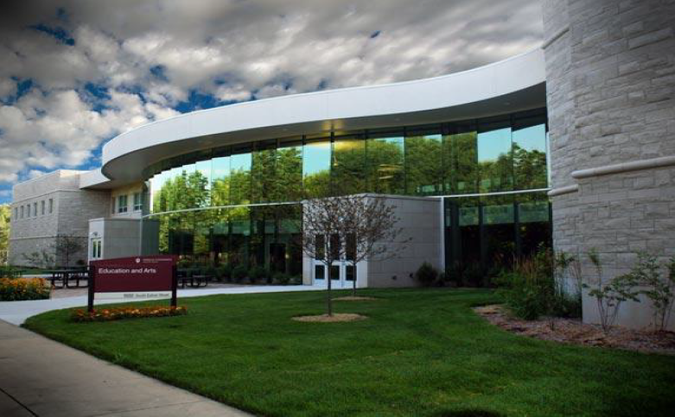



|  |  |  |  |
| --- | --- | --- | --- |
| **A**  Kamri Aguirre  Carla Aguirre-Sanchez  Nissy Alvarez-Chavez  Liliana Ambriz  **B**  Cheyanne Barkowski  Bailey Bell  Cassee Berger  Bryce Blosser  Paige Blower  Jacob Bowman  Makenna Brantley  Julia Brenneman  Lexi Breveard  Olivia Bull  **C**  Olivia Carney  Jenelle Castillo  Tia Champion  Bella Cooper  Alondra Coria  Gavin Cornelison  Kimberley Cossman  Kayla Crowson  Alejandro Cuautle-Quintana  **D**  Grace Daniels  Delaney Davis  Emily Davis  Haley Davis  Brittany DeShone  Calina Deutscher | **E**  Hannah Eaton  Sydney Emmans  Jennifer Escobar  Ana Estrada  **F**  Sarah Farrough  Alyson Fields  Madison Figg  Madison Frost  **G**  Jazimine Gilley  Joselyn Gonzalez  Camille Gooden  Lilly Gorman  Ryleigh Grott  Carla Gutierrez-Espinoza  **H**  Dallas Hammond  Sydney Hanna  Riley Harris  Caitlin Hennessy  Byonka Hernandez  Irissa Herrera  Kourtney Hojara  Kennedy Holst  Halle Hopple  Taylor Hostetler  Eva Huss  Elise Hutts | **J**  Mary Japa  Catrianna Johnson  Paige Jones  **K**  Audra Kiszka  Ellee Kling  **L**  Anika LeeVan  Joey Lewis  Isaac Lillie  Grace Lynch  **M**  Lucas Margraf  Scott Mark  Breanna Marrs  Yadira Martinez-Alonzo  McKenna Mast  Audrie McNamara  Emma Meert  Aubrey Menting  Haley Miller  Jessica Castillo-Moreno  Maritsa Arroyo- Moreno  Madison Morrett  Mia Morrison  Tiffany Murphy | **N**  Jacob Nava  Zoie Neterer  Gage Nierzwicki  **O**  Julie Okrzesik  **P**  Adam Parrish  Avery Penrod  Joshua Perez-Grahovac Jr  Courtney Petrosky  Emily Philson  Haley Pletcher  Kristyn Principe  **R**  Ava Raker  Isabel Reynoso  Robby Richards IV  Brianna Roth  **S**  Becky Saeger  Tamara Salameh  Jared Schoof  Owen Schroeder  Emily Sharp  Lauryn Sherwood  Grace Shoemaker  Madyson Shumaker  Shawn Smallwood  Steven Smith  Loredana Tirri Spano  Sarah Stachowski  Maddie Stark |
| **T**  Claire Treber  Anna Turpin  **U**  Sophia Ullery  **V**  Madi VanderMel  Alyssa Volk  **W**  Myra Walz  Jessica Warren  Allison Washburn  Carlie Weaver  Emily Werner  Hanna Wilcox  Daviana Winfield  Allie Wojtysiak  Aryana Wolferman  Kara Wright  **Y**  Brayden Yates |  |  |  |